Mohanad Mahmoud Sayed

1- How many pods exist on the system?

2- How many Nodes exist on the system?

🡪 There is one worker node which is node01

3- Create a new pod with the nginx image.

Image name: nginx

4- Which nodes are these pods placed on?

* On node: node01

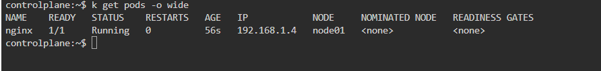

5- Create pod from the below yaml using kubectl apply command

apiVersion: v1

kind: Pod

metadata:

name: webapp

namespace: default

spec:

containers:

- image: nginx

imagePullPolicy: Always

name: nginx

- image: agentx

imagePullPolicy: Always

name: agentx

Firstly, let’s create a file.yml for this example to create the pod

Then, let’s apply

6- How many containers are part of the pod webapp

* Webapp pod has 2 containers: nginx and agentx

7- What images are used in the new webapp pod?

* nginx and agentx

(but nginx only is used, agentx is not pulled from dockerhub as shown in the ss in question 5)

8- What is the state of the container agentx in the pod webapp

🔹 **State:** Waiting  
🔹 **Reason:** ImagePullBackOff

9- Why do you think the container agentx in pod webapp is in error?

**🡪Reason:** Kubernetes is trying to pull the image agentx but **fails** because it likely does **not exist on a public registry like Docker Hub**

This causes the container to go into the **ImagePullBackOff** state — which means it tried to pull the image, failed, and now backs off from trying again immediately.

10- Delete the webapp Pod.

11- Create a new pod with the name redis and with the image redis123.

* Name: redis
* Image Name: redis123

Firstly, let’s create a file.yml for this example to create the pod

Then, let’s apply

🡪Note: the image is not running because redis123 is not found on dockerhub to pull

12- Now change the image on this pod to redis.

Once done, the pod should be in a running state.

Firstly: let’s edit the pod file to change the image name from redis123 to redis

Then, let’s apply

* The pod is in the running state

13- Create a pod called my-pod of image nginx:alpine

14- Delete the pod called my-pod

